**DAILY ONLINE ACTIVITIES SUMMARY**

|  |  |  |  |  |  |  |  |
| --- | --- | --- | --- | --- | --- | --- | --- |
| **Date:** | **01 June 2020** | | | | **Name:** | **K ISHA HEGDE** | |
| **Sem & Sec** | **4th sem, 2nd year** | | | | **USN:** | **4AL18CS031** | |
| **Online Test Summary** | | | | | | | |
| **Subject** | | **COMPLEX ANALYSIS, PROBABILITY AND STATISTICAL METHODS (18MAT41)** | | | | | |
| **Max. Marks** | | **30** | | **Score** | | **30** | |
| **Certification Course Summary** | | | | | | | |
| **Course** | **INTRODUCTION TO INFORMATION SECURITY** | | | | | | |
| **Certificate Provider** | | | **Great Learning** | **Duration** | | | **3.25 hrs** |
| **Coding Challenges** | | | | | | | |
| **Problem Statement:2 program** | | | | | | | |
| **Status: Executed** | | | | | | | |
| **Uploaded the report in Github** | | | | **Yes** | | | |
| **If yes Repository name** | | | | **[https://github.com/iishaii/locked-down_coding](https://github.com/iishaii/locked-down_coding" \o "https://github.com/iishaii/locked-down_coding)** | | | |
| **Uploaded the report in slack** | | | | **Yes** | | | |

Online Test Details: (Attach the snapshot and briefly write the report for the same)

Certification Course Details: (Attach the snapshot and briefly write the report for the same)

Coding Challenges Details: (Attach the snapshot and briefly write the report for the same)

**ONLINE TEST SUMMARY**:

Today 18MAT41 also conducted for 30 marks which is divided into two parts 10 questions of 1 mark and 10 questions of 2 marks at 9:25 am.

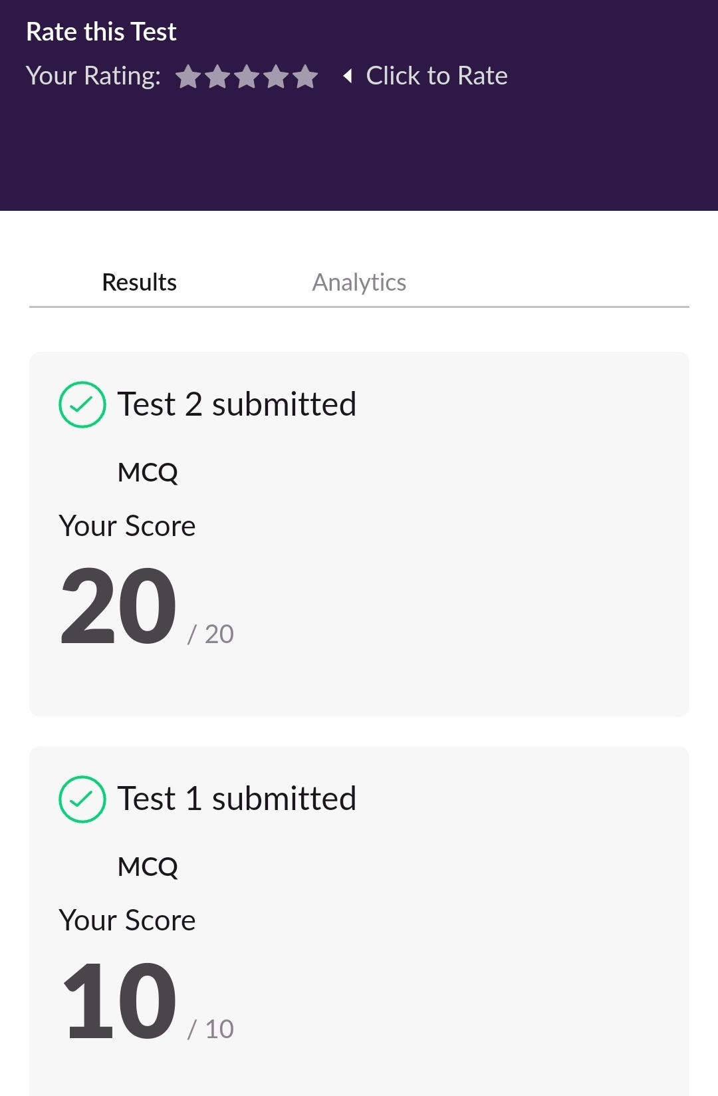

**CERTIFICATION COURSE SUMMARY:**

* Today I completed INTRODUCTION TO CYBERSECURITY quiz and also secured a certificate.

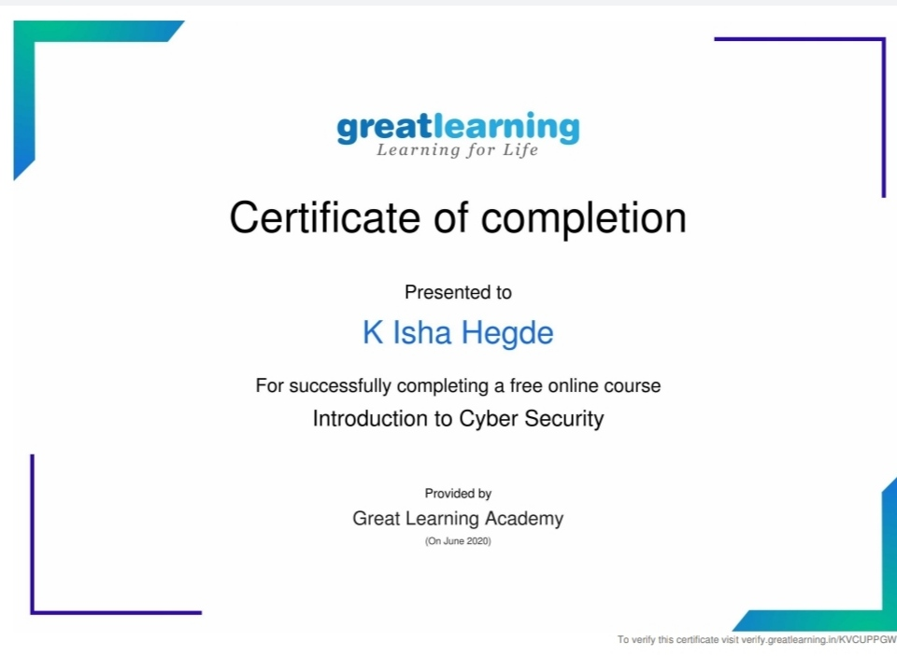

I continued with INTRODUCTION TO INFORMATION SECURITY and covered

* Introduction to software security lesson two



* And also attended two webinar related to it





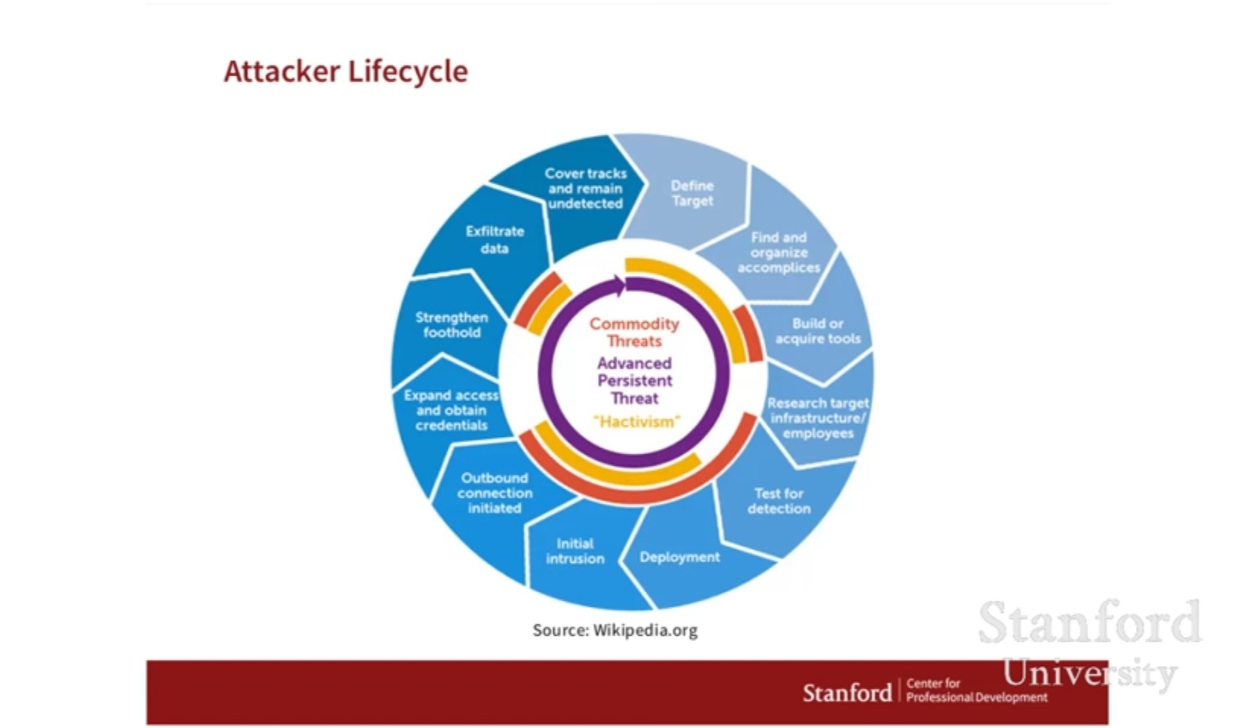

**CODING CHALLENGE:**

Today I solved 2 coding challenge,

1.Java program for **Define a class Point with two fields x and y each of type double. Also, define a method distance (Point p1, point p2) to calculate the distance between points p1 and p2 and return the value in double... Use Math.sqrt() to calculate the square root.**

**2.** **Given an array arr [] of size N and an integer K. The task is to find the count of subarrays such that each subarray has exactly K distinct element.**

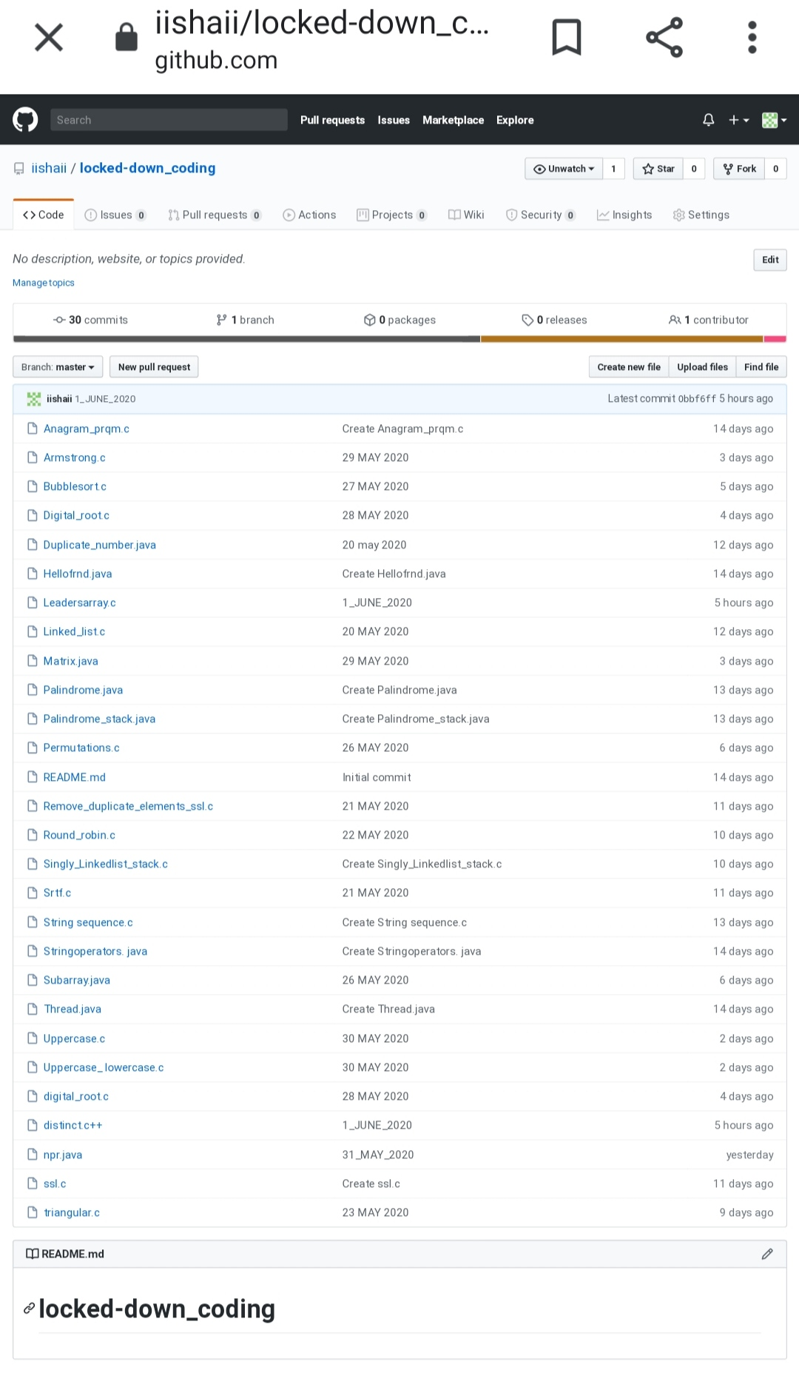

**SOLUTION : I have uploaded the solution of the above 4 coding problems in my GitHub repository.**

**[https://github.com/iishaii/locked-down_coding](https://github.com/iishaii/locked-down_coding" \o "https://github.com/iishaii/locked-down_coding)**